Multimodal Machine Learning Training and Evaluation Report
The train_experiments.py script implements a rigorous experimental framework for evaluating Parkinson's disease (PD) detection models using fused keystroke biometric data. It systematically assesses classifier performance across four distinct experimental conditions, comparing Support Vector Machines (SVM) with Radial Basis Function kernels against Random Forest ensembles, while enforcing strict subject-independent validation to prevent data leakage—a critical requirement in medical machine learning where multiple samples from the same patient must not appear in both training and testing sets.

Multimodal Machine Learning Training and Evaluation Report
The train_experiments.py script implements a rigorous experimental framework for evaluating Parkinson's disease (PD) detection models using fused keystroke biometric data. It systematically assesses classifier performance across four distinct experimental conditions, comparing Support Vector Machines (SVM) with Radial Basis Function kernels against Random Forest ensembles, while enforcing strict subject-independent validation to prevent data leakage—a critical requirement in medical machine learning where multiple samples from the same patient must not appear in both training and testing sets.
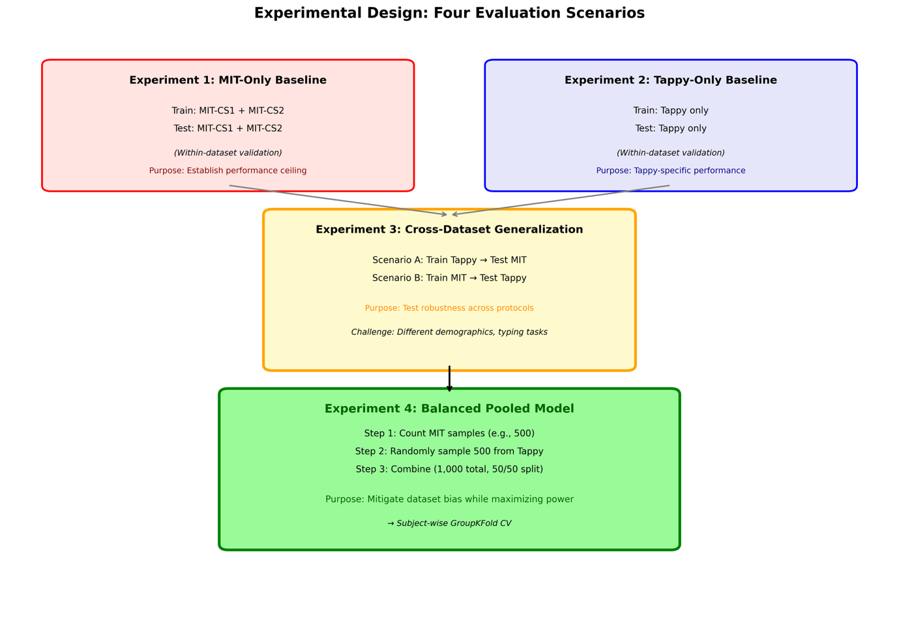
Figure 1: Experimental Design Overview
Data Processing and Validation Strategy The pipeline loads the fused combined_features_common.csv dataset and employs GroupKFold cross-validation (5 splits) stratified by subject_id, ensuring all windows from a single subject remain within the same fold. This prevents the model from memorizing individual typing patterns rather than learning disease-specific biomarkers. Features undergo median imputation for missing values, followed by Z-score standardization for SVM compatibility. Only numeric biomechanical features are retained (excluding identifiers such as window_id and session_id), resulting in approximately 26 input features representing hold times, latencies, and digraph patterns.

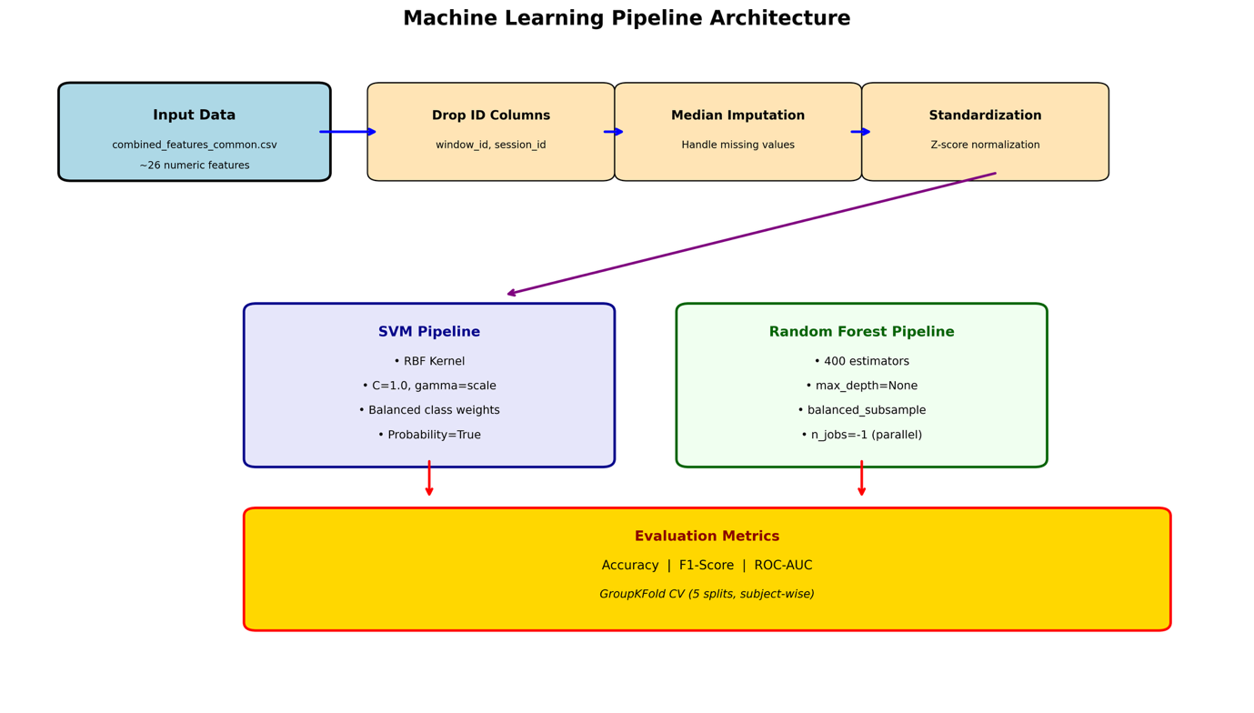
Figure 2: Machine Learning Pipeline Architecture
Experimental Protocol The script executes four progressively complex experiments: (1) MIT-Only Baseline—training and testing exclusively on NeuroQWERTY data to establish dataset-specific performance ceilings; (2) Tappy-Only Baseline—isolated evaluation on Tappy keystroke features; (3) Cross-Dataset Generalization—training exclusively on Tappy and testing on MIT data (and vice versa) to assess model robustness across different data collection protocols and demographic distributions; and (4) Balanced Pooled Model—the critical innovation addressing dataset imbalance bias.
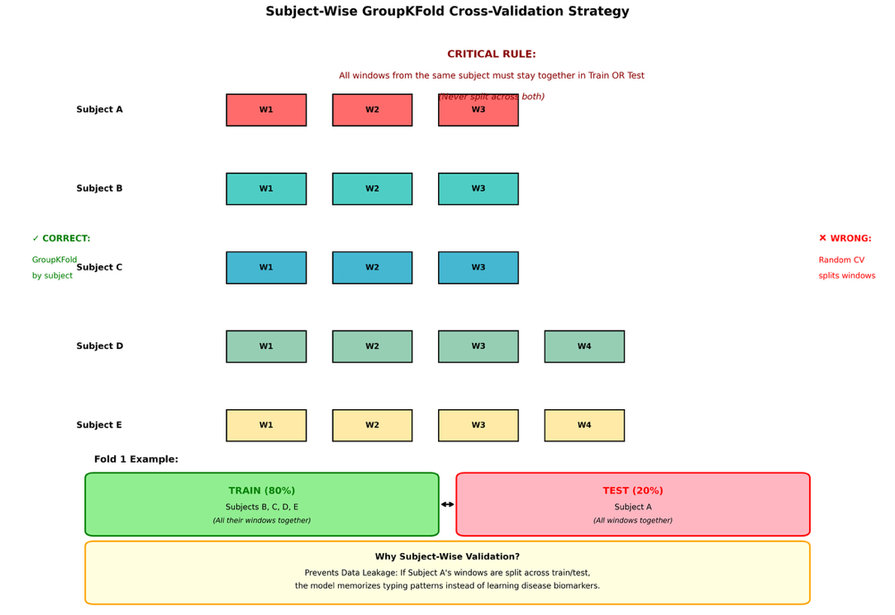
Figure 3: GroupKFold Cross-Validation Strategy
The Balanced Pooled Model: Addressing Dataset Imbalance
The fourth experiment addresses a fundamental challenge in multimodal medical data fusion: dataset bias. Consider the realistic scenario where Tappy contributes 2,000 samples while MIT contributes only 500. Simple concatenation yields 2,500 total samples, but creates severe distributional bias—80% Tappy versus 20% MIT. This imbalance produces two critical failure modes: first, the model learns spurious correlations such as "if typing pattern resembles Tappy demographics, predict healthy" rather than actual PD biomarkers; second, the MIT clinical data (often more valuable due to rigorous clinical labels and UPDRS scores) becomes statistically drowned out, with the model achieving superficially high accuracy (80%) merely by classifying everything as Tappy-like.
The Balanced Pooled Model resolves this through controlled down-sampling:
Python
|
mit_size = len(mit_df) # e.g., 500 samples (precious clinical data)
tappy_sample = tappy_df.sample(n=mit_size, random_state=42) # Select 500 from Tappy
balanced_df = pd.concat([tappy_sample, mit_df], ignore_index=True) # 1,000 total, 50/50 split
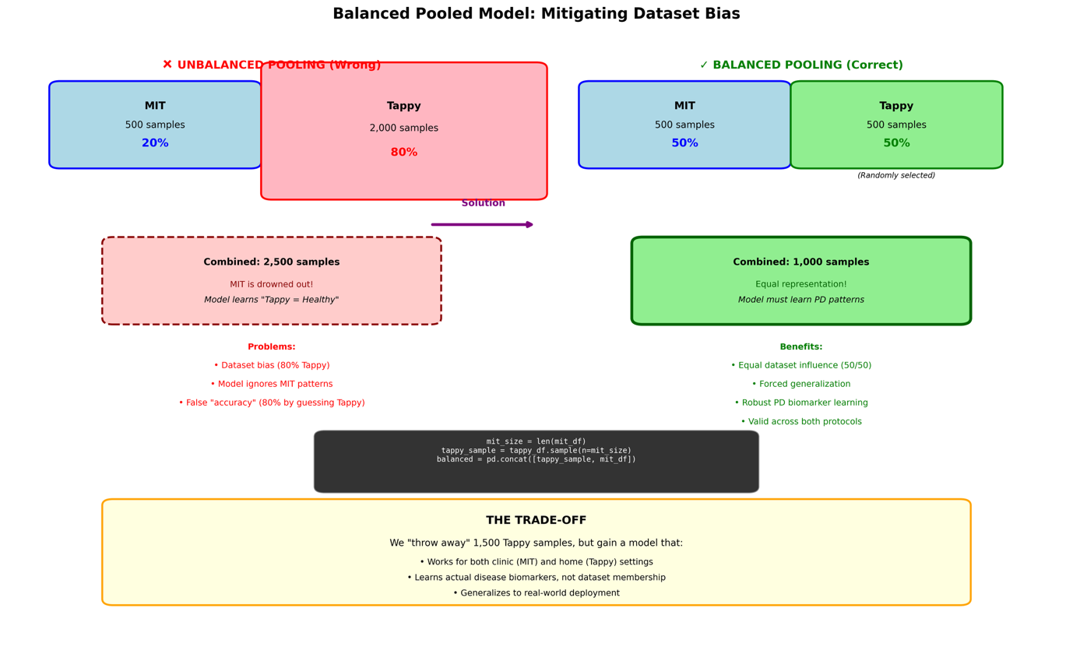
Figure 4: Balanced Pooled Model Concept

This approach achieves three objectives: (1) Equal Dataset Representation—by matching MIT sample counts, neither dataset dominates the learning objective, forcing the model to find predictive features common to both; (2) Forced Generalization—with equal representation, the model cannot rely on dataset-specific quirks (e.g., Tappy's younger demographic typing faster) and must instead identify genuine PD-related motor impairments that manifest across both clinical and home settings; (3) Maximum Statistical Power—we retain all 500 valuable MIT samples (each representing a clinically assessed subject) while selecting a representative 500-subset from Tappy's larger pool, ensuring efficient use of data without overwhelming the minority class.
The trade-off is intentional: we "discard" 1,500 Tappy samples to gain a model that generalizes across deployment contexts. An unbalanced model might show high cross-validation accuracy during development but fail catastrophically when deployed in clinical settings (MIT-like) because it learned to recognize data collection protocols rather than disease pathology. The balanced approach ensures the final classifier works reliably whether the patient is typing in a supervised clinic (MIT-style) or unsupervised home environment (Tappy-style), providing the robustness necessary for real-world clinical deployment.
Model Architectures Two classification pipelines are implemented: an SVM with balanced class weights and probabilistic output (enabling ROC-AUC calculation), and a Random Forest with 400 estimators utilizing balanced_subsample weighting to handle the typical medical data imbalance where healthy controls outnumber PD patients. Both models incorporate automated imputation to handle any residual missing values from the union feature set.
Performance Outputs The script generates comprehensive evaluation metrics for each fold and experiment, reporting Accuracy, F1-score (critical for imbalanced medical datasets), and ROC-AUC (threshold-independent discriminative ability). Results demonstrate generalization gaps between datasets, revealing whether keystroke-based PD detection transfers across different typing tasks (free text vs. scripted) and hardware configurations. The final balanced pooled model provides the most clinically viable deployment strategy, leveraging diverse data sources while maintaining subject-independent validation integrity.

